1. Microscopy, its properties and applications. Optics basics - reflection, refraction, diffraction, point spread function, thin lens, numerical apperture. Microscopy construction, objective, eyepiece, magnification, resolution. 3D microscopy, fluorescence microscopy, phase contrast, dark field.
2. X-rays, spectrum, construction, generation, detection, interaction with tissue, attenuation, medical use, imaging properties, contrast agents.

Nice recap: [How X-rays see through your skin - Ge Wang](https://www.youtube.com/watch?v=gsV7SJDDCY4)

1. Tomography imaging, principles and examples. Computer tomography, principles and construction. Beam hardening. Hounsfield units. Attenuation in inhomogeneous region. Radon transform, sinogram, central slice theorem, Reconstruction techniques - filtered backprojection, iterative methods. Fan-beam geometry. 3D CT imaging and reconstruction, spiral (helical) method, pitch. Clinical applications of CT.

Central slice theorem: <https://www.youtube.com/watch?v=YIvTpW3IevI>

1. Radiation dose, effective dose, radiation safety.
2. Ultrasound imaging. Ultrasound propagation, reflection, refraction, attenuation, propagation speed, scattering. Characteristic (specific) impedance, reflection. Ultrasound generation and detection. RF signal processing. Ultrasound image reconstruction, modes. Clinical applications.

[Clarius: Fundamentals of Ultrasound 1 (Physics)](https://www.youtube.com/watch?v=cI7ULKNhVcw)

( [Clarius: Fundamentals of Ultrasound 2 (Equipment & Usage)](https://www.youtube.com/watch?v=jxGUId2lBaA) )

[Ultrasound medical imaging | Mechanical waves and sound | Physics | Khan Academy](https://www.youtube.com/watch?v=sTcqtljxLOk), cca od 1:00

1. Doppler principle, Doppler ultrasound imaging, continues and pulsed wave system, demodulation, limits on the maximum speed. Clinical applications.
2. Ultrasound contrast agents, harmonic imaging. 3D ultrasound.
3. Magnetic resonance imaging - principles and clinical use. Nuclear spin in magnetic field, Larmor frequency, magnetization, relaxation, excitation, precession, flip angle, time constants T1, T2, T2*.

[Introduction to MRI Physics](https://www.youtube.com/watch?v=Ok9ILIYzmaY)

T1, T2: [MRI | Introduction In the Physics of MRI and It's Clinical Relevance](https://www.youtube.com/watch?v=bTLRs-hpe9g)

1. MRI excitation sequences (FID, spin echo, gradient echo, inversion recovery), time diagrams, properties and parameters (TE,TR). Signal intensity.
2. Slice selection, frequency and phase encoding, k-space, Fourier imaging and reconstruction. k-space sampling, field of view (FOV), aliasing. Spatial resolution.
3. Fast MRI techniques (multislice MRI, parallel MRI), contrast, T1,T2,PD-weighed sequences. MRI hardware - superconductive magnet, coils. Safety.
4. Chemical shift in MRI, contrast agents, angiography, flow imaging, diffussion MRI, tagged MRI, spectroscopy.
5. Functional brain MRI, BOLD effect, hemodynamic response, fMRI experiment design and evaluation - linear model, statistical testing. Groupwise (Bonferroni) correction.
6. Radioactivity, radioactive decay, activity and half-live, effective half-life. Radionuclide production, generator, cyclotron. Nuclear imaging devices (gamma camera, SPECT, PET) - principles and clinical use. Reconstruction methods, attenuation correction. Coincidence detection in PET.

PET and SPECT: [PET vs SPECT | Nuclear medicine](https://www.youtube.com/watch?v=lXkndmLV_ps)

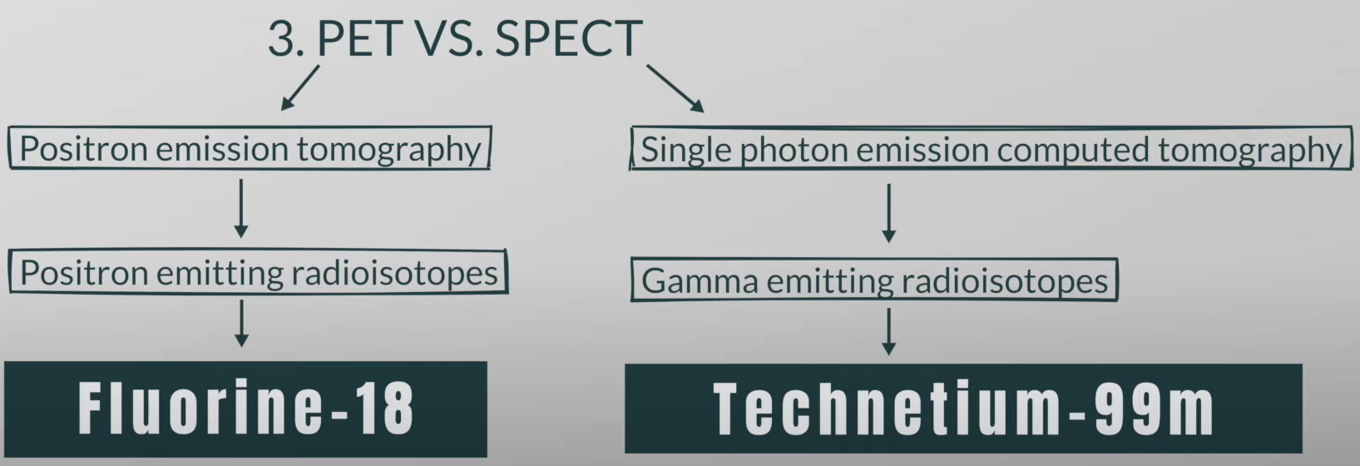

**PET**